CPRE 8th November Meeting, Transport Options & future of A27 – John Hurwood

Look at the view on this slide; it embodies much of what I wish to say.

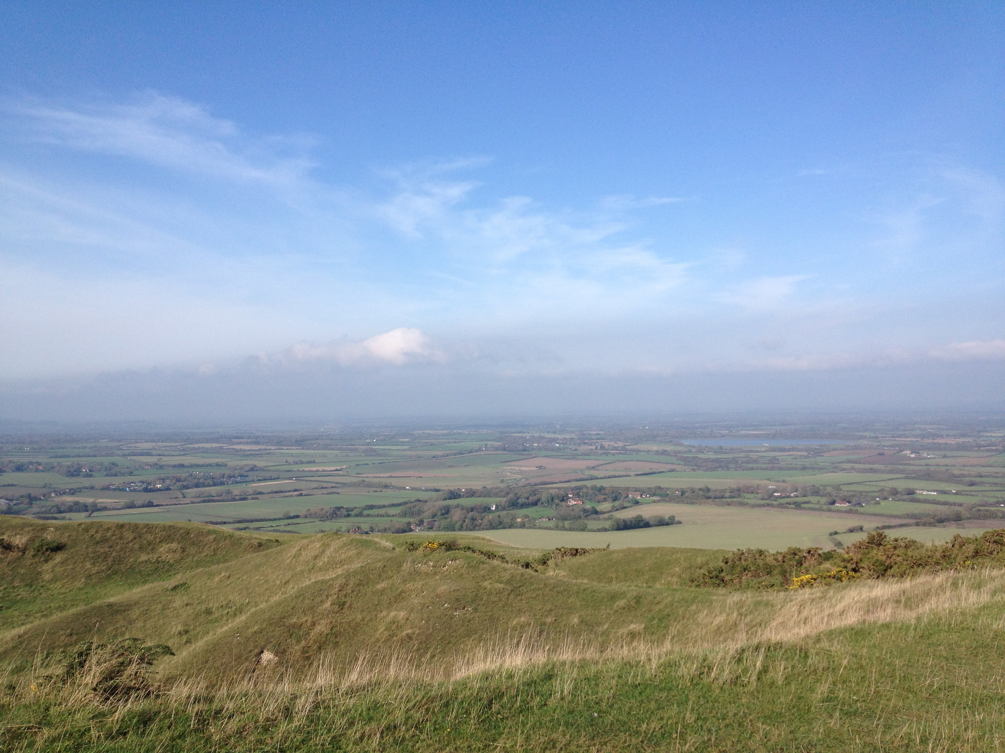

The view is of the LOW WEALD that forms the outlook from the South Downs Way.

      - Note lack of development
- Spot the A27
- Spot the main railway line - they are not obtrusive and they blend ….

GENERAL for whole A27 - Reasons given for pressure for A27 “improvements”

- Accident reduction & need for safety improvement

- Increase capacity of road, with two main views:

      - Perception of avoiding delays and speeding journeys
      - Enable developers to build on new sites.

LOCAL for Wealden Area, the issues from our perspective:

- SAFETY Many poor junctions such as Wilmington (horses), Milton Street, Berwick, etc., each has no safe way to cross or join the A27 and safety improvements are urgently needed. Same route, same capacity but safer and reduced accidents.

- CAPACITY To increase capacity of road will require a major new route. This would turn the road into a major blot on the landscape, involving dual carriageways, bridges at each minor road, major works at each end of the road, not necessarily a cure to delays, as roundabouts simply cause long traffic queues on “improved” roads e.g. Lewes & Polegate bypasses)

- DEVELOPERS A lot of Pressure to build new roads comes from developers, locally we had the Honey Farm proposals, where the main issue was a westward expansion of Polegate close to the National Park with the A27 link road they showed with many new roundabouts for further future developments. Similarly we had earlier suggestions of a major new development in the Berwick area that died mostly because of a lack of local road capacity. Would a new road trigger this again? We need to protect the setting of the South Downs, the National Park boundary is drawn too close to the scarp slope and we do not wish to see the setting of the National Park ruined by large scale development following a large road! We need to be aware that Government policy is in favour of developers funding road schemes. Look also at The Bexhill/Hastings Link road, which is to regenerate (i.e. develop) green fields, rather than to solve traffic issues – the road to nowhere!

- ALTERNATIVES We need to look at options to reduce road use; we have a railway alongside the road. If a percentage of those who jam the road every rush hour could be helped to go by train the jams would be drastically reduced. (Look at how much reduced the problems is during school holidays when traffic volumes are reduced). Similarly at the same time that we are discussing new road schemes ESCC are discussing major cuts to the local rural bus services which will result in more cars on the road, bus services should be improved not cut. Subsidies for both of these actions would be better value than spending on more roads. AND, Whist all this pressure is being applied to spend money on the A27, we have ESCC deciding to make no money available for safe cycle routes that would help reduce demands on the road and improve people’s lives.

- Final message is to be very cautious about pressure for “improving” the A27, as we do not know where it will lead, scepticism and caution are needed if we are to keep our local piece of rural England. BEWARE !

